Sri Lanka Institute of Information

Technology



Lab Submission

<Lab sheet No-7>

**<IT24102224>**

**<Fernando K.A.N.N.>**

**Discrete Mathematics | IT2120**

B.Sc. (Hons) in Information Technology

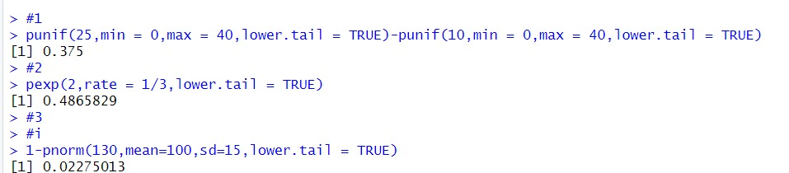

**3)ii)**